Commercially Sexually Exploited Children (CSEC)
In Our Own Backyard

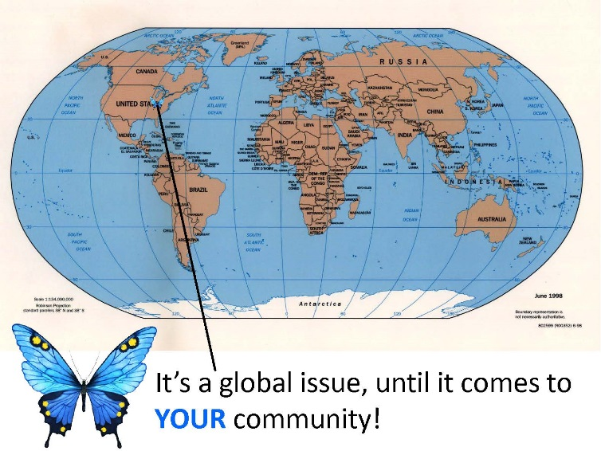

Traffickers target children because of their vulnerability. The market demand for young victims is high. The common age of entry into commercial sex trafficking is 12-14 years old. Despite current efforts, the threat of child sexual exploitation remains very real, and can occur in the home, on the street, or over the Internet. The most vulnerable include runaways, children in group homes, and children in foster care.
Attendees will learn how to recognize a victim of human or sex trafficking; understand what services are the most beneficial, what is available in your county and the State of Indiana, and how your colleagues are tackling this difficult industry. Indiana is making strides in addressing this issue statewide. The current status of legislation will be discussed, together with the system response.
Ensuring that all children come of age without being impacted by sexual trauma or exploitation is more than a criminal justice issue, it is a societal issue. Judicial leadership, community, law enforcement and professional intervention along with appropriate psychological treatment are the keys to successfully combating this threat to the kids in our own back yard.

2016 JUDGE DAVID’S COMMUNITY IN-SERVICE
JOIN US TO LEARN MORE ABOUT THIS VITALLY IMPORTANT TOPIC!
OCTOBER 5, 2016
8:00 a.m. – 1:00 p.m.
WITHAM HEALTH SERVICES PAVILION
BOONE COUNTY FAIRGROUNDS, LEBANON, INDIANA
Registration information: www.communityinservice.com

